Supplementary Material
Synergistic enhancement of methane yield and odor control in pig manure anaerobic digestion via micro-aeration pretreatment
Hong Zhaoª, Xiao-Bo Zhouª, Shu-Han Zhangª, Fan Liuª, Teng-Xia He^{a, c,} *, Guang-Liang Tian^{b}, Xi-Wen Liangª, Man-Man Zhangª, Yi-Xiao Liaoª

_{a} Key Laboratory of Plant Resource Conservation and Germplasm Innovation in Mountainous Region (Ministry of Education), Guizhou Key Laboratory of Agricultural Microbiology, College of Life Sciences, Guizhou University, Guiyang, Guizhou, China
_{b} Institute of New Rural Development, Laboratory of Pollution Control and Resource Utilization Technology for Mountainous Livestock and Poultry Farming, Guizhou University, Guiyang, Guizhou Province, China
_{c} Key Laboratory of Karst Georesources and Environment (Guizhou University), Ministry of Education, Guizhou University, Guiyang, Guizhou, China

List of supplementary materials
5 texts, 2 tables, and 12 graphs
Text 1 Community assembly processes
Text 2 Community stability and ecological strategies
Text 3 Identification of key differential species
Text 4 Dynamics of the core community
Text 5 Analysis of community functional potential
Table S1 The basic characteristics of pig manure raw materials.
Table S2. Alpha diversity index of pig manure pretreated with micro-aeration.
Fig. S1 Device diagram of the micro-aeration pretreatment system.
Fig. S2 Device diagram of the sequential batch AD system
Fig. S3 Analysis of differences in Alpha diversity among groups.
Fig. S4 Composition of microbial communities at the phylum levels
Fig. S5 Composition of microbial communities at the class levels
Fig. S6 Composition of microbial communities at the order levels
Fig. S7 Composition of microbial communities at the species levels
Fig. S8. Relative contributions of generalized and specialized specie
Fig. S9. LEfSe multi-level species tree, LDA discriminant histogram, Circos diagram and ring evolutionary tree diagram of microorganisms during anaerobic digestion of pig manure after micro-aeration pretreatment
Fig. S10. Bar chart of species difference test
Fig. S11. Species difference test for two samples
Fig. S12. Functional prediction of PICRUSt2 and species distribution in ecological community during anaerobic digestion of pig manure after micro-aeration pretreatment

Text 1 Community assembly processes
Analysis using the infer community assembly mechanisms by phylogenetic‑bin‑based null model (iCAMP) framework revealed that community assembly in the untreated group CK was primarily governed by homogeneous selection (48.0%), reflecting strong environmental filtering under consistent anaerobic conditions (Fig. 4E). In group A4.6, the contribution of stochastic processes such as drift increased significantly to 61.5%, indicating that moderate aeration alleviated environmental filtering and allowed greater random colonization, thereby promoting the formation of communities with higher diversity and evenness (Fig. 4E). In group A13.9, deterministic processes regained prominence, suggesting that high‑intensity aeration imposed a new and potent selective pressure.
These patterns were further supported by the beta‑deviation index (CK, A0, A4.6, and A13.9 were 39.1%, 74.7%, 73.4%, and 53.0%, respectively) (Fig. 4F). The high index values in groups A0 and A4.6 indicate that moderate aeration or pretreatment itself exerted strong deterministic selection, efficiently filtering for functional taxa. The relatively lower index in group A13.9 may be attributed to extreme disturbance, while selection remained active, the severe reduction in the survivable species pool during pretreatment likely enhanced the stochastic component of subsequent community assembly [1].

Text 2 Community stability and ecological strategies
Analysis of the community stability index (AVD) indicated that groups A0 and A4.6 exhibited the highest community stability (Fig. 6C). Niche breadth analysis revealed that generalist species dominated (>80%) in all groups, whereas the proportion of neutral species decreased markedly following aeration (from 6.6% in CK to <3.5% in aerated groups; Fig. S8). These findings suggest that aeration pretreatment enhances community stability by reducing stochastic components and reinforcing structural determinism and functional predictability.
Assessment of community dispersal capacity (A13.9 > A4.6 > CK > A0) provided a dynamic perspective (Fig. 6D). The high dispersal ability observed in group A13.9 may result from niche vacancies created by severe disturbance, though this was accompanied by functional simplification. In contrast, the moderate dispersal capacity of group A4.6 balanced environmental adaptability with functional optimization, thereby supporting long‑term system stability.

Text 3 Identification of key differential species
Multilevel statistical analysis was employed to accurately identify key taxa driving community differentiation. The Kruskal‑Wallis test revealed 338 genera with highly significant differences in abundance among the four groups (p < 0.01), confirming the broad impact of treatments (Fig. S9). Subsequent pairwise comparisons showed that the number of differential species between groups A0 and A4.6 (207) was considerably lower than that between each of these groups and CK or A13.9 (both approximately 286) (Fig. S10). This statistically supports the high structural similarity between A0 and A4.6, suggesting that comparable aeration intensities drive the system toward similar disturbance‑response intermediate states.
LEfSe analysis identified signature taxa in each group (Fig. S9A and S9B). Groups A0 and A4.6 shared core markers within the Enterobacteriaceae, while group A13.9 exhibited a unique marker profile, including genera such as Bacteroidetes_vadin HA17 and Methanothrix. These markers clearly delineate the succession from the original fermentative community (CK) to an efficient syntrophic consortium (A0/A4.6), and further to a specialized functional community (A13.9).
In addition, the Circos diagram illustrated that aeration intensity significantly influenced the abundance distribution of two key methanogenic archaea (Fig. S9C). The relative abundance of Methanosarcina in groups CK, A0, A4.6, and A13.9 was 0%, 4%, 3%, and 93%, respectively, while that of Methanothrix was 0%, 79%, 20%, and 1%, respectively. High‑intensity aeration (A13.9) promoted the dominance of Methanosarcina, a genus whose broad‑spectrum substrate utilization enables it to adapt to varying redox conditions while sustaining methanogenic activity [2]. Methanothrix, an obligate anaerobic archaeon with high acetate affinity, exhibited greater competitiveness under low‑oxygen conditions [3]. Notably, in the A4.6 group, it maintained an abundance of 20%, indicating that this aeration intensity preserved its essential anaerobic niche. Methanosarcina and Methanothrix can control odor by efficiently consuming key precursors of odor gases, such as volatile fatty acids, hydrogen, and acetic acid to reduce the substrate supply generated by sulfur and nitrogen containing compounds [4]. Under optimal aeration (A4.6), these two archaea formed a metabolically complementary network. This functional synergy not only reduced malodorous gases precursors via aerobic processes but also retained essential methanogenic functional redundancy and system stability for the subsequent anaerobic digestion stage.

Text 4 Dynamics of the core community
Analysis based on species occurrence frequency revealed distinct and persistent structural shifts in the community (Fig. S9C). Following aeration pretreatment, the abundance of persistent species, those present in all samples, decreased sharply. In contrast, intermediate species, detected in two to three samples, increased markedly to over 75% and became the dominant component. These results suggest that aeration pretreatment drove functional enrichment and directional assembly of the microbial community. Specifically, aeration disrupted the original core community and promoted the establishment of a new consortium supported largely by treatment‑specific, functionally pivotal taxa. While this restructured community enhances resource allocation toward highly efficient microorganisms, it also increases the system of dependence on the specific environmental conditions to which these specialized taxa are adapted [5].

Text 5 Analysis of community functional potential
The effects of micro-aeration pretreatment on methane production and odor control were elucidated at the gene level using PICRUSt2 functional prediction (Fig. S12A and S12B). Compared with the control group (CK), the micro-aeration pretreatment group exhibited significant enrichment of pathways related to the sulfur oxidation system, sulfate reduction, nitrogen fixation, and degradation and assimilation of C1 compounds (Fig.S12A). Concurrently, genes associated with type 2 and type 4 bacterial secretion systems were upregulated, reflecting an enhanced microbial capacity for sulfur and nitrogen conversion and the degradation of small organic molecules [6]. Key enzymes, including pyruvate synthase and NADH oxidoreductase, participate in energy and redox metabolism and work in concert with protein disulfide isomerase to maintain cellular homeostasis (Fig. S12B). This coordinated enzymatic activity facilitated the conversion and removal of sulfur- and nitrogen-containing odor gases.
Regarding carbon metabolism, the enrichment of pathways such as fatty acid β-oxidation, the tricarboxylic acid cycle, acetyl-CoA synthesis, the tetracarboxylic butyric acid cycle, and the 3-hydroxypropionate bicycle was observed (Fig.S12A). This enrichment significantly improved the degradation efficiency of volatile fatty acids and the supply of acetyl-CoA. Furthermore, the upregulation of amino acid biosynthesis pathways, including those for aromatic amino acids, histidine, glycine, and lysine, provided essential nutrients and reducing power to support the growth and metabolism of methanogens (Fig.S12A). Increased expression of enzymes such as deoxyribonuclease and RNA polymerase further ensured the stability of genetic information processing under stress conditions, sustaining high metabolic activity in functional microbial populations (Fig.S12B). In summary, micro-aeration pretreatment systematically activated sulfur and nitrogen conversion, carbon flux redirection, cofactor supply, and oxidative stress adaptation to inhibit odorous gas formation and promote methane anabolism.

Table S1. The basic characteristics of pig manure raw materials.
Indicators | Values
Total solids (%) | 22.46±1.17
Volatile solids (%) | 75.12±2.35
Total organic acids (mg/L) | 972.29±70.35
Electrical conductivity (mS/cm) | 11.30±1.05
ORP (mV) | -335.22±10.24
pH | 7.12±0.37

Table S2. Alpha diversity index of pig manure pretreated with micro-aeration.
Sample/Estimators | ACE | Chao | Shannon | Simpson | Coverage | Sobs
CK | 432.21+9.08 | 432.40+9.41 | 4.50+0.05 | 0.03980+0.00205 | 0.99996+0.00007 | 432.00+8.72
A0 | 392.90+9.97 | 392.71+10.00 | 4.51+0.04 | 0.3445+0.00349 | 0.99996+0.00002 | 392.67+10.07
A4.6 | 442.36+10.36 | 442.18+10.23 | 4.79+0.06 | 0.2235+0.00481 | 0.99994+0.00006 | 442+10.00
A13.9 | 483.51+24.50 | 484.21+25.63 | 4.65+0.06 | 0.02521+0.00124 | 0.99972+0.00005 | 481.67+16.04

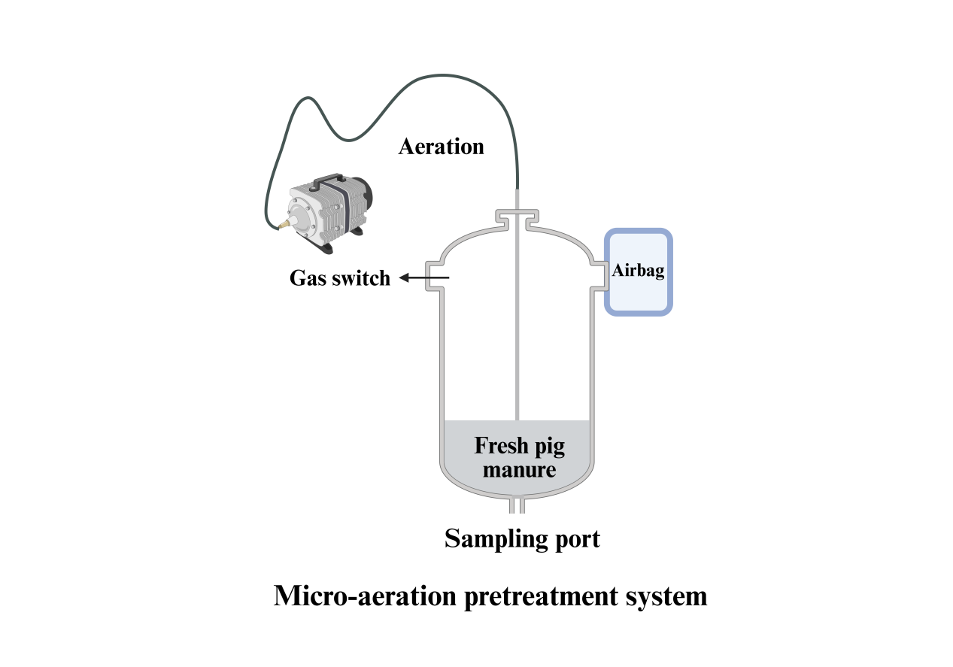
Fig. S1. Device diagram of the micro-aeration pretreatment system.
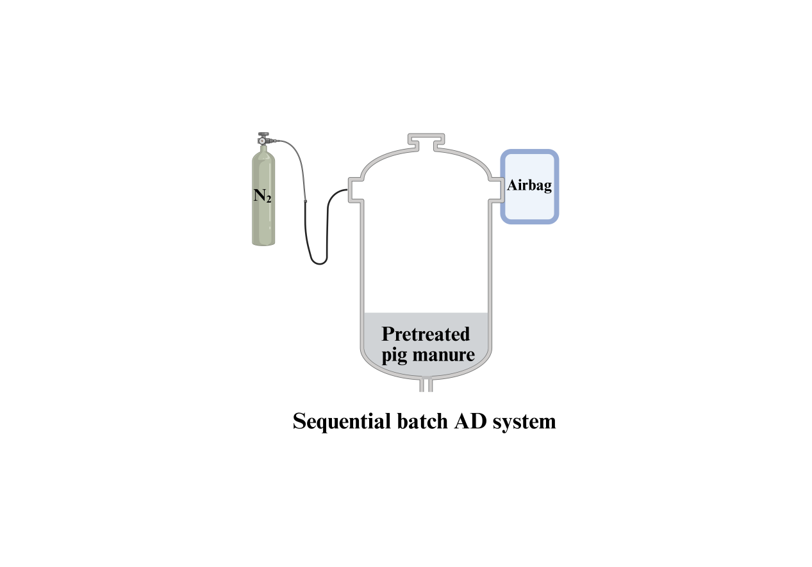
Fig. S2. Device diagram of the sequential batch AD system
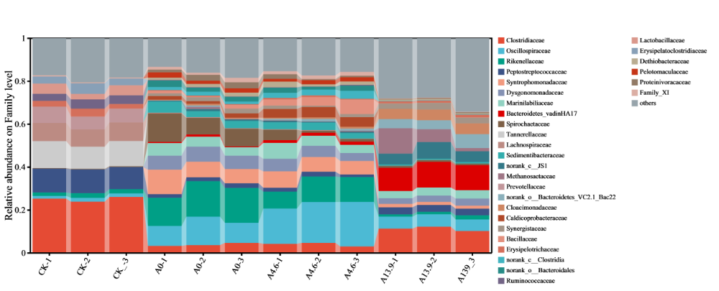
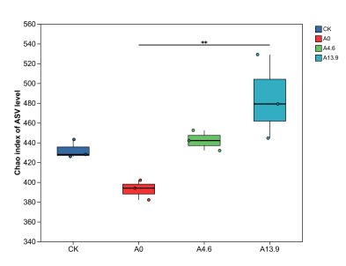
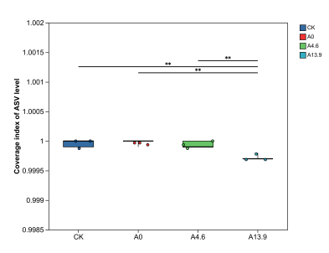
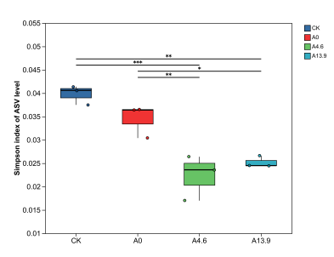
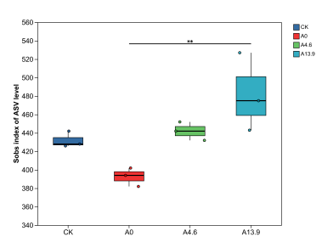
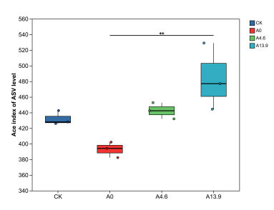
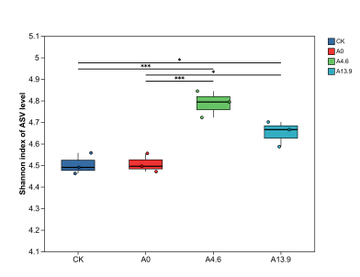
Fig. S3. Analysis of differences in Alpha diversity among groups.
A
B
C
D
E
F
Fig. S4. Composition of microbial communities at the phylum levels.
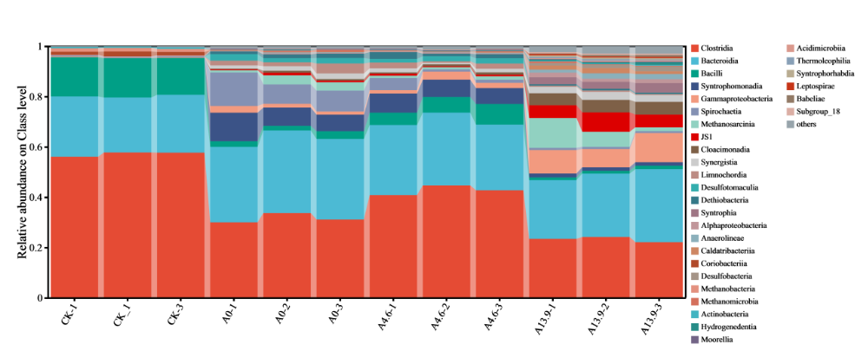
Fig. S5. Composition of microbial communities at the class levels.
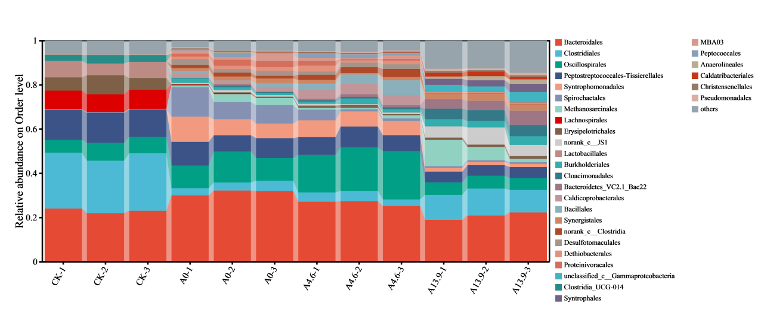
Fig. S6. Composition of microbial communities at the order levels.
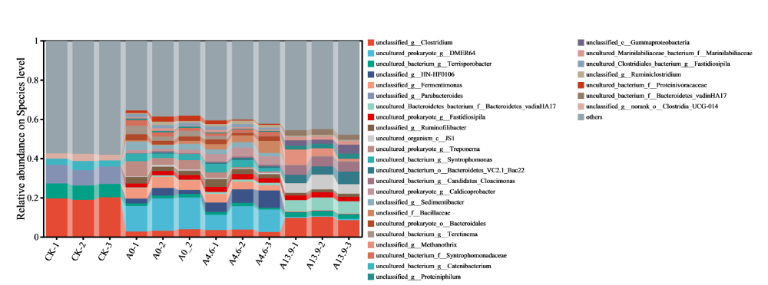
Fig. S7. Composition of microbial communities at the species levels.
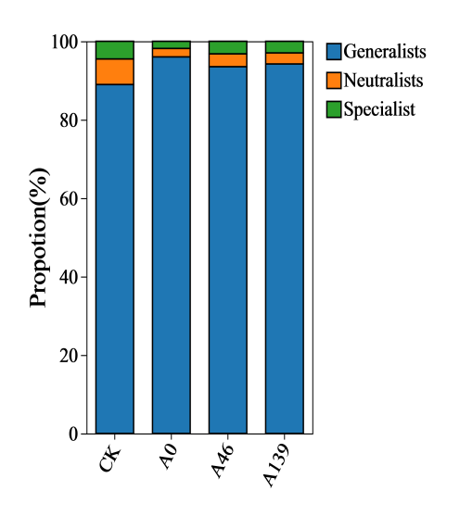
Fig. S8. Relative contributions of generalized and specialized species.

Fig. S9. LEfSe multi-level species tree (A), LDA discriminant histogram (B), Circos diagram (C) and ring evolutionary tree diagram (D) of microorganisms during anaerobic digestion of pig manure after micro-aeration pretreatment.

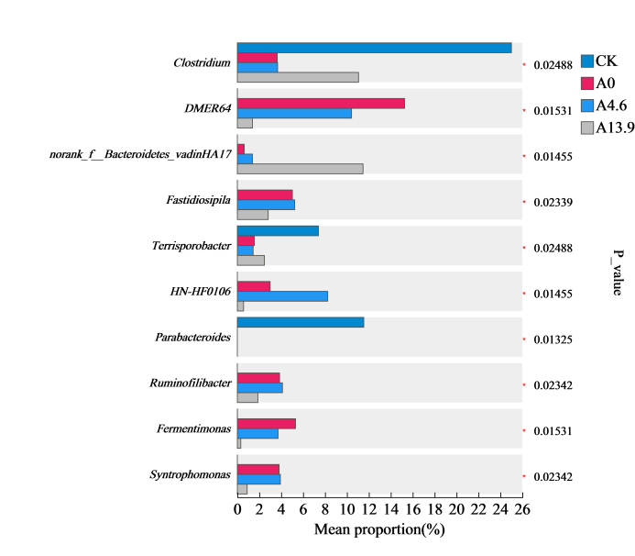
Fig. S10. Bar chart of species difference test.
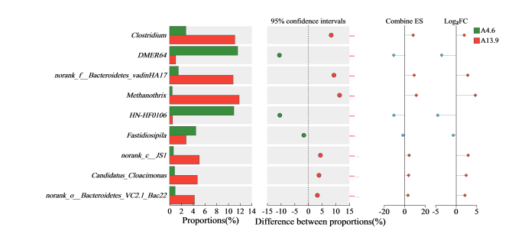
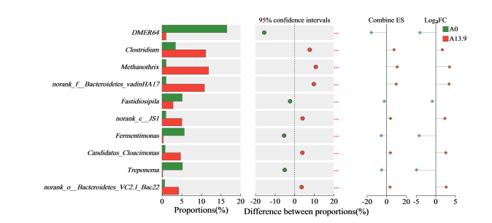
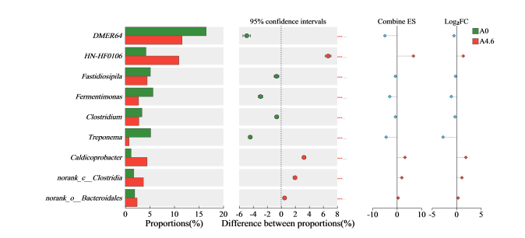
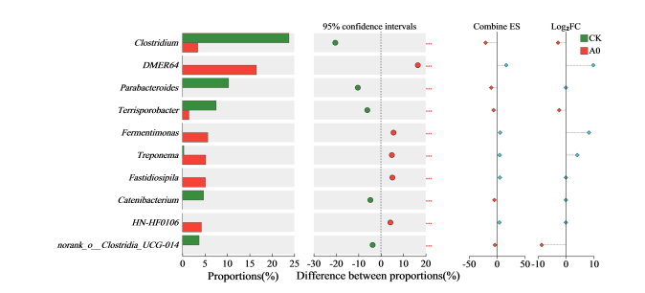
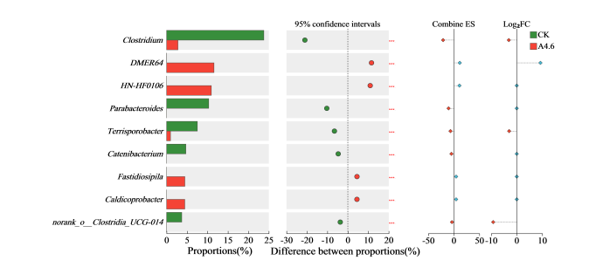
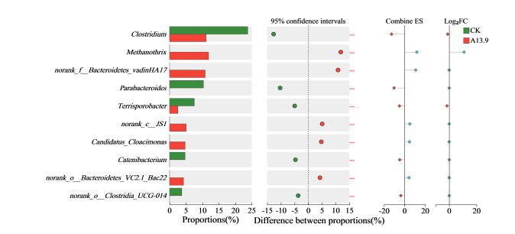
Fig. S11. Species difference test for two samples.

Fig. S12. Functional prediction of PICRUSt2 (A: heatmap of KO and B: heatmap of enzyme) and species distribution (C) in ecological community during anaerobic digestion of pig manure after micro-aeration pretreatment.
References
[1] Zheng, Y.K., Wang, J.R., Niu, X.J., Su, X.T., He, X.Y., Hu, Y.X., Zhao, D.M., Chen, D.Y., Lin, Y., Li, K., 2025. Ferrihydrite enhance performance in anaerobic digestion of pig manure: Methane production, Feammox and metabolic pathway. J. Water Process. Eng. 72. https://doi.org/10.1016/j.jwpe.2025.107621.
[2] Kadam, R., Jo, S., Park, J., 2026. Importance of substrate mixture ratio optimization on efficient anaerobic co-digestion of organic wastes generated in livestock sector: Insights into process performances and metagenomics. Bioresour. Technol. 441. https://doi.org/10.1016/j.biortech.2025.133561.
[3] Zhu, R., Wang, D.H., Zheng, Y., Zou, H., Fu, S.F., 2022. Understanding the mechanisms behind micro-aeration to enhance anaerobic digestion of corn straw. Fuel. 318. https://doi.org/10.1016/j.fuel.2022.123604.
[4] Falk, J.M., Kjeldsen, P., Buck, C., Scheutz, C., 2026. Treatment of manure methane emissions in a full-scale biofilter by microbial oxidation. Waste Manage. 209. https://doi.org/10.1016/j.wasman.2025.115214.
[5] Holatko, J., Valtera, M., Hammerschmiedt, T., Kucerik, J., Kintl, A., Baltazar, T., Ryant, P., Malicek, O., Latal, O., Mustafa, A., Brtnicky, M., 2025. Manure induced transformations in soil nutrient stocks, microbial activity and multifunctional diversity: A six year long study in Chernic Phaeozem. Soil Use. Manage. 41(2). https://doi.org/10.1111/sum.70054.
[6] Chen, X.B., Sun, P.Y., Zhuang, Z.X., Ahmed, I., Zhang, L.Z., Zhang, B., 2024. Control of odorants in swine manure and food waste co-composting via zero-valent iron /H2O2 system. Waste Manage. 174, 390-399. https://doi.org/10.1016/j.wasman.2023.12.018.

* Corresponding author. Address: Zhijuan East Road, Huaxi, Guiyang, Guizhou 550025, China. Tel.: 0851-88292178; Fax: 0851-83621956. E-mail address: txhe@gzu.edu.cn (T.X. He)

